Harris Technology Roadshow
for Elementary, Middle and High School Students

Hands-On Gears for Students
Bicycles, cars, household appliances, spacecraft…what do these very different objects all have in common? They all rely on gears to operate! This lesson introduces mechanical engineering concepts to students through a fun, memorable, and educational lesson on gears.

Why do students enjoy this workshop so much?
- The projects are straightforward and tailored for the age of the student.
- The projects are designed to peak curiosity and allow students to discover new concepts on their own.
- The students work together in teams and often teach each other.

Lego® Gear Assemblies
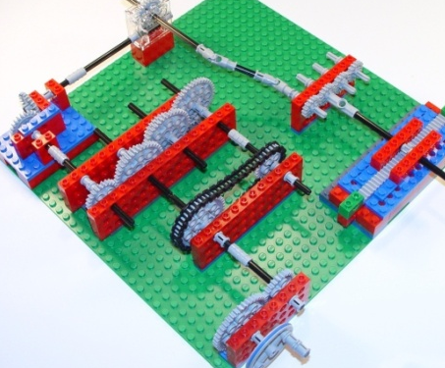
Several different pre-built Lego® gear assemblies are provided in a kit to each group of students. The highlight of this workshop is when the students are challenged to use all of these to construct a “Rube Goldberg” gear train contraption. This gives the students an opportunity to use their new knowledge of gears and get immediate "real world" feedback. An integrated learning environment provides a vehicle to interact with students on the topics of design, innovation, problem solving, and teamwork while at the same time teaching math, science, and technology.

Harris Provides the Engineers
Harris is proud to offer engineers to lead and assist in these projects. These are people who enjoy science and math and hope to motivate the next generation to consider a career in science or engineering. They will not only share their knowledge with the students but also their enthusiasm for a field that is often misrepresented as boring.

Workshop Setup
During a typical workshop, 20-24 students will be divided into teams with one Lego® gear kit per team. Our engineers will give a brief overview of mechanical engineering and encourage the students’ participation as they explore gears. Examples provided through videos, pictures, and illustrations, will help students relate concepts back to the real world. As the teams finish constructing their gear trains, the engineers will follow up with individual and group discussions of the concepts just covered. Typical sessions run between 45-60 minutes.

Topics
The lesson plans will demonstrate math and science concepts using the Lego® gear assemblies. Some of the topics covered include:
- What gears are, and where they are used
- Gears used to turn corners
- Chain drives
- Gear ratios
- Rack and pinions

Classroom Requirements
Although we are in the process of developing lessons for other grades, The Hands-On Gears Lesson is currently only available for grades 3 through 6. The classroom should have enough tables or desks to accommodate teams of 2-3 students. Additionally, it will need a projector with a computer connection, so Harris engineers can show a multimedia presentation.

Contact Information
Please send your requests for a visit to outreach@harris.com. Please include date, time, nature of visit, how many students, etc. Harris off-Fridays are preferred, and it’s easier to recruit volunteers for half day events or less. We will schedule on off-Fridays first come, first served, and we will confirm if we are able to support within 2 weeks of the event date.

Brevard Public School Contact:
Ginger Davis – Davis.Ginger@Brevardschools.org

.

