The following files need to be downloaded from directory
cs.fit.edu/Projects/REMI/DATA/ to view results of dynamic reconstruction:
dog_output.xlsx
new_output_human.xlsx
new_output_ncat.xlsx
output_dog_CPU.Vol
output_dog_GPU.Vol
output_humanCPU.Vol
output_humanGPU.Vol
output_ncatCPU.Vol
output_ncatGPU_1_.Vol

We have output coefficients as .VOL files here. The following shows each of the coefficient’s dimensions and how to open one coefficient on Amide visualization tool. Each file actually contains all coefficients, one after another on the z dimension. You may need to shift opening position in the file in order to open respective coefficient.

For NCAT Data,
1, Open by "Amide": "File"->"Import File (specify)”-> “Raw Data”
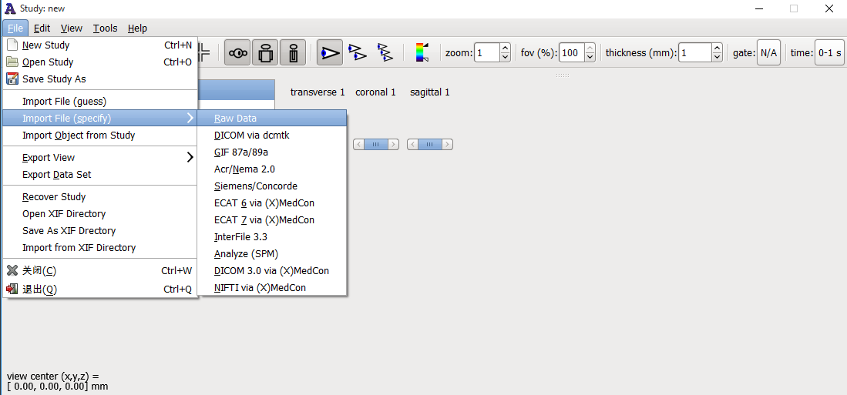
2, Choose the correct reconstruction image file path
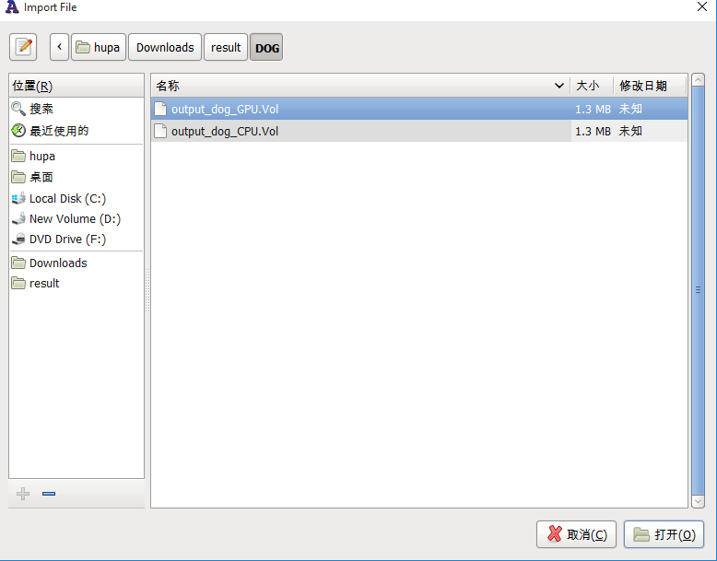
3. Set the correct parameters
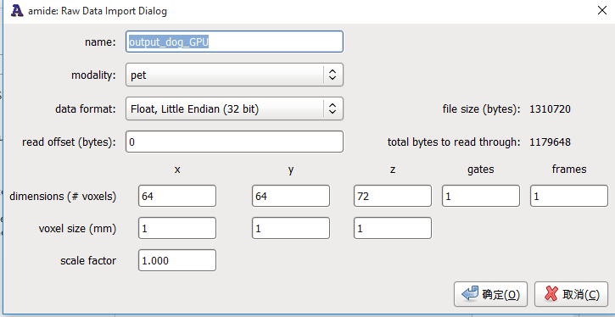

For Dog Data:
The correct parameters should be:
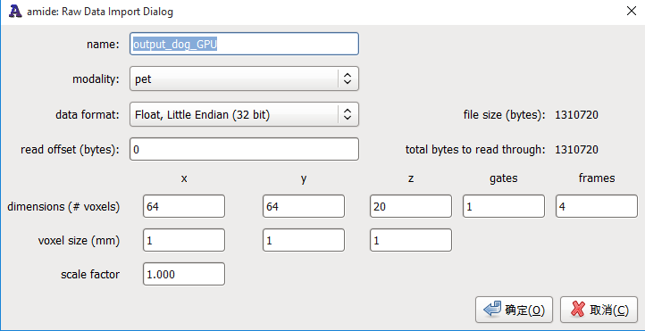

For Human Data:
The correct parameters should be:
